Comments on EnigmaKernelRev3.cpp
by
Tom Cuff

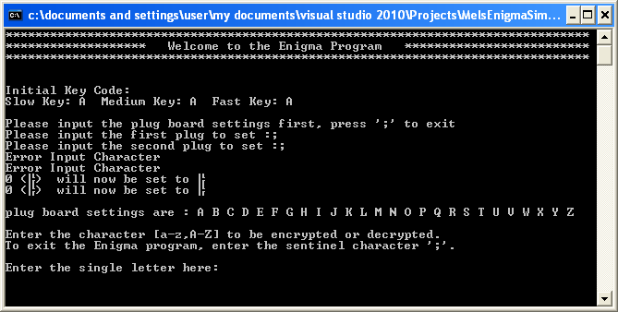

Comment #1: With respect to the line “Please input the plug board settings first, press ‘;’ to exit”. What is the User exiting from: 1) the program, or 2) just the plug board setup routine? In addition, there is no explanation of what, exactly, the User is supposed to enter if they are not entering the ‘;’ character.

Comment #2: When is the User supposed to enter the sentinel character, ‘;’: 1) after the line “Please input the first plug to set :”, 2) after the line “Please input the second plug to set :”, or 3) after both these lines?

Comment #3: If the User enters the sentinel character, ‘;’, after both the lines “Please input the first [second] plug to set :” , why do the lines “Error Input Character” and “0 (??) will now be set to ??” appear? How can the User have entered an erroneous input character if they were told to enter the ‘;’ character?

Comment #4: The outgoing messages from the plug board setup routine need to be more user-friendly. The User does not care what is in the code, and certainly does not want to reverse engineer the meaning of the code, or try to read the mind of the coder.

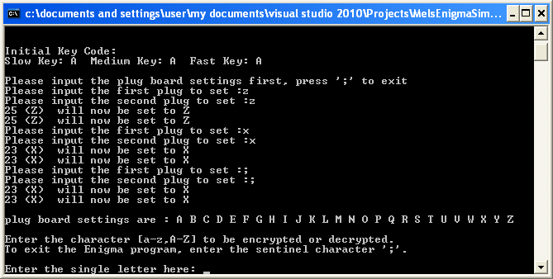

Comment #5: Why does the plug board setup routine allow the User to input the same letter twice? It appears that line “plug board settings are : …” is correct for the duplicate inputs, but why allow duplicate inputs in the first place?

Comment #6: When the sentinel character, ‘;’, is entered, why do the next two lines, “23 (X) will now be set to X”, appear?

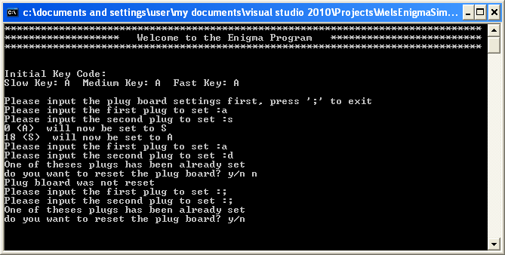

Comment #7: If the User enters the same plug twice for two different patch cords, they are asked if the want to reset the plug board. However, if they choose not to reset the plug board, they are forced to latter on when they try to exit the plug board setup routine. Why is there this double-jeopardy?

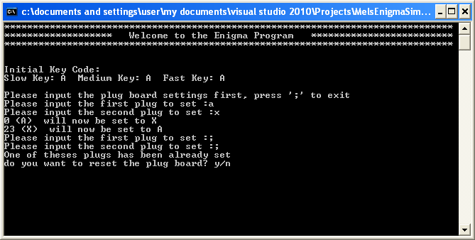

Comment #8: What is going on here? Why does the line “One of these plugs has been already set” appear?

